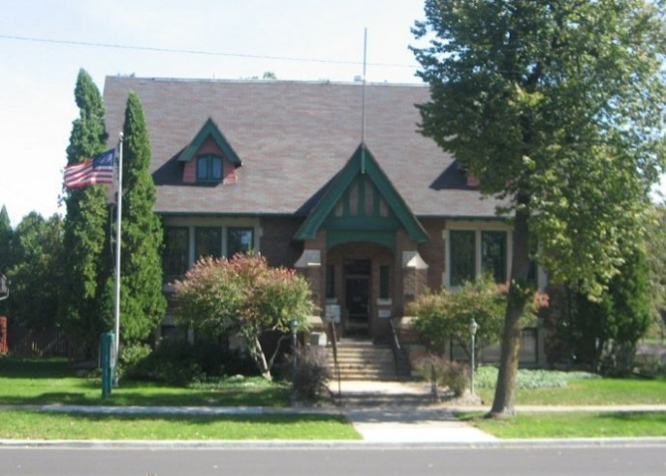

Holly History and Genealogy Center

The Holly History and Genealogy Center, built in 1914, serves as the Waupaca Historical Society’s main building and houses a museum, research facility and lower-level meeting room.
In 2001, the WHS purchased the historic Carnegie Library, formerly the Waupaca Public Library, on Main Street. Much of the original details and furniture remain in the building, including the original windows and woodwork.
The meeting room is available to individuals, groups and businesses for rent. The lower level has a small kitchen with sink and refrigerator for rental use. If interested in renting, please contact the Waupaca Historical Society at (715) 256-9980 or director@waupacahistoricalsociety.org.

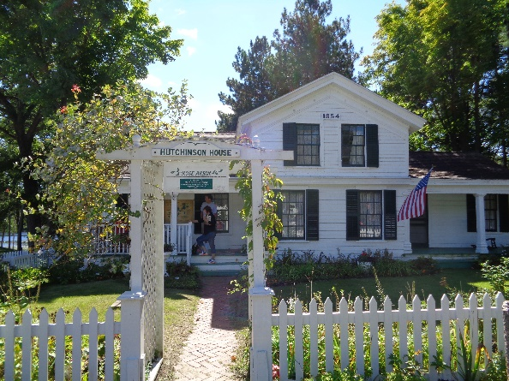

Historic Waupaca Depot

Just past the Oak Street Bridge sits one of Waupaca's historic landmarks—the former Soo Line railroad depot.
For many years, the depot was an important part of the Waupaca community. In 1907, the Wisconsin Central spared no expense to build a brand-new depot for this important tourist and shipping location.
In January 1965, Soo Line passenger service ended in Waupaca. The depot served as an agent's office and section crew quarters until it closed in 1987.
In 2004, the Waupaca Historical Society acquired the depot. Volunteers have spent many hours restoring the building and grounds.
The Railroad Depot, located at 525 Oak Street, can be rented for weddings, parties, meetings and other events. If you are interested in renting the Depot, please call (715) 256-9980 or director@waupacahistoricalsociety.org.

Hutchinson House

Step back in time at Waupaca’s historic Hutchinson House. The Hutchinson House, built in 1854, is the oldest existing home in Waupaca. This farm house was originally built on the corner of West Fulton and Franklin Streets.
The Waupaca Historical Society purchased the house in 1956 and moved it to South Park in 1957. The museum showcases the Victorian era and displays artifacts from Waupaca’s early settlers. The home is open during the summer or by appointment during park events.
The King Cottage was purchased from the Wisconsin Veterans Home and moved behind the Hutchinson House in 1975. Today it includes an exhibit on the history of the
Wisconsin Veterans Home and its cottages. It is available for rentals by small groups by calling (715) 256-9980 or director@waupacahistoricalsociety.org.
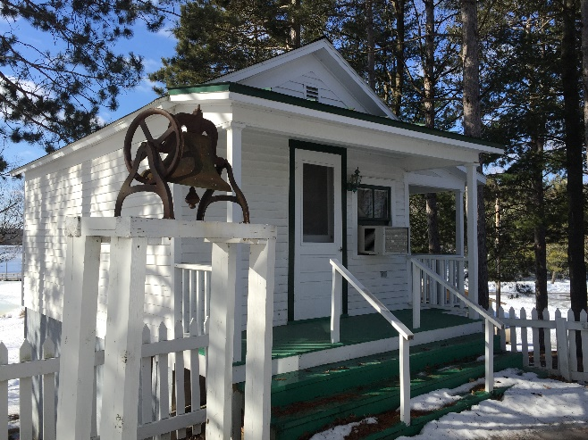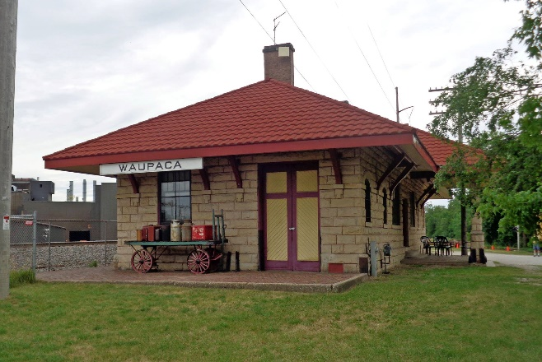 The King Cottage

HISTORICAL VENUES
(not including B & B’s)
Waupaca, Wisconsin

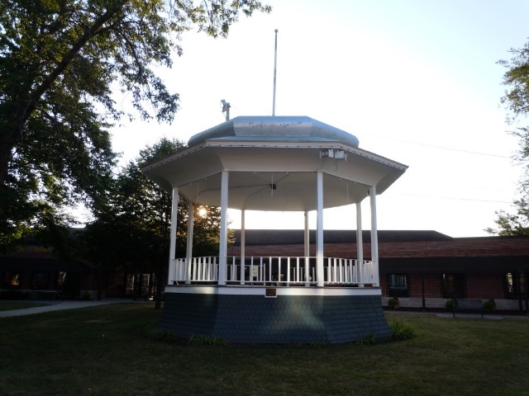

Historic Bandstand

Besides the sites noted in this brochure which are all either in or within a few miles of the City of Waupaca, there are other historical places of interest located in and around Waupaca.

- Historic Yankee Village of Rural (1850’s)
- Bandstand, Waupaca City Square (1889)
- Browne Law Office, oldest continuously operating law office in Wisconsin (1854)
- Many historic homes in the city built from 1870’s to 1920’s.
- Historic Homes from 1850’s along Rustic Road No. 23 between Rural and Hartman Creek State Park

Printed with support of Waupaca Historical Society
2018

Places to celebrate – Places to visit

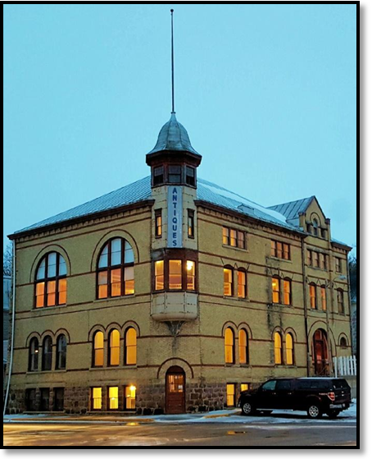
Waupaca Danes Hall
Built in 1894, Danes Hall stands as a landmark at the North end of Waupaca’s Main Street. Designed by famed Wisconsin Architect William Waters, Danes Hall was built by Waupaca’s Danish immigrants as a meeting place and social hall. This historic gathering place hosted dances, weddings, musical performances, political rallies, and even early Waupaca High School graduations. The building has two meeting rooms on its main level and a large ballroom on its upper level. A restaurant/coffee house operated in the lower level, serving Danish pastries and classic Danish cuisines.
Danes Hall is currently being restored to its former grandeur and will re-open with a restored ballroom, meeting rooms, and maybe even a Danish Bakery. Once the restoration is complete, Danes Hall will be available to hosts weddings, concerts, fine arts exhibits and community events. Follow the progress at:
www.DanesHallWaupaca.com
Like us on Facebook at:
www.facebook.com/DanesHall

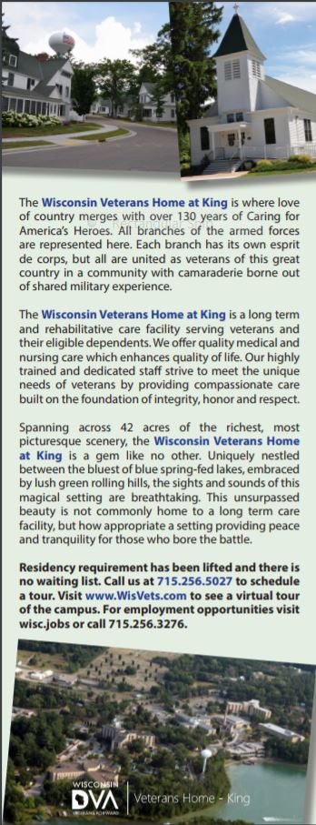

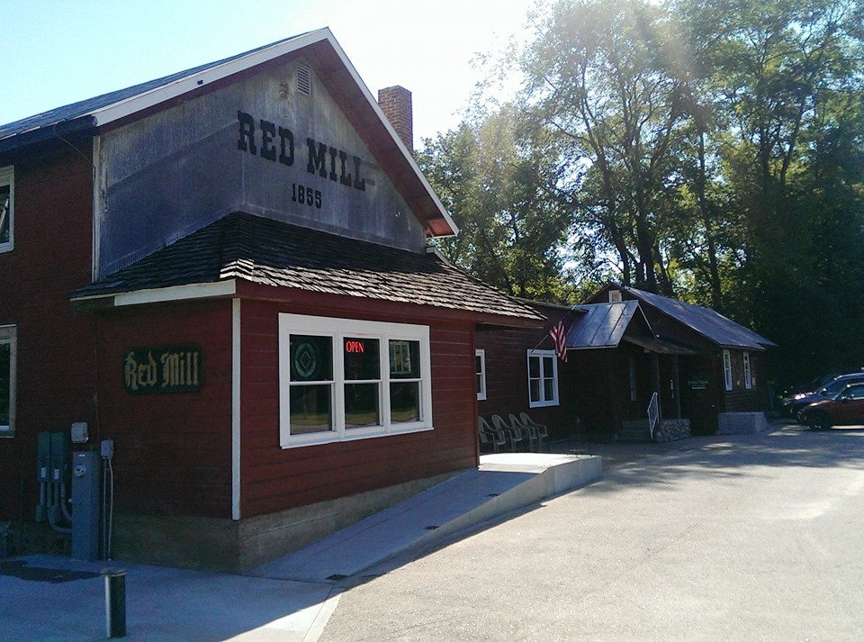
The Red Mill
Built in 1855, the Red Mill sits along the Crystal River at N2190 Cty K. A former grist mill, the Red Mill is now a gift shop and coffee & ice cream shop. The grounds hold a small chapel in the woods that can be used for weddings and a walking covered bridge that helps visitors step back in time. Upstairs in the Red Mill is a small gathering room that can hold up to 25 people.

The shops can be enjoyed year-round. Sandwiches and soup are offered each day for limited hours. A complete coffee menu and large ice cream selection are available daily as well. The gift shop has a large variety of unique gifts and home décor and features an old-time candy room. Visit the Red Mill Coffee and Gift Shop. Sip a cup of coffee and enjoy a relaxing lunch while shopping for yourself and others. Contact Sheila at the Red Mill at 715-258-7385 to reserve event space. Like us on Facebook at www.facebook.com/redmillwaupaca.

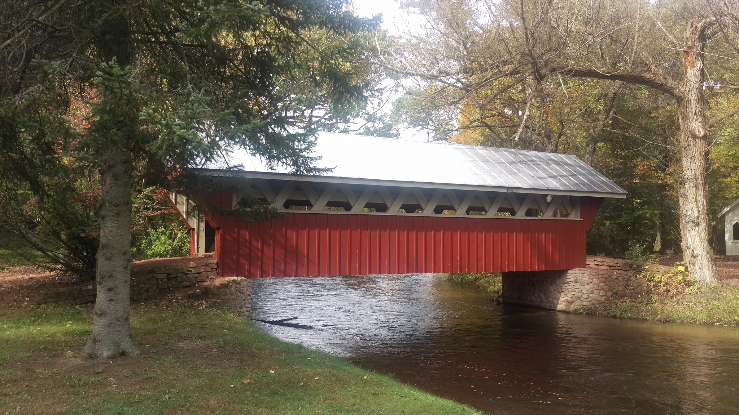 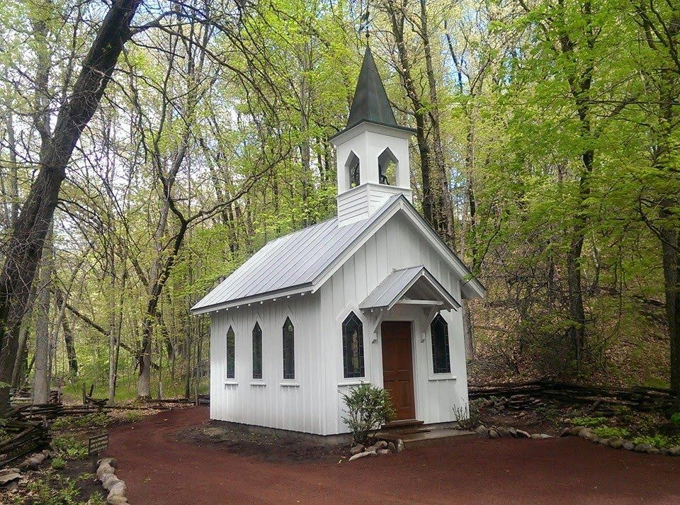 Covered Bridge Chapel

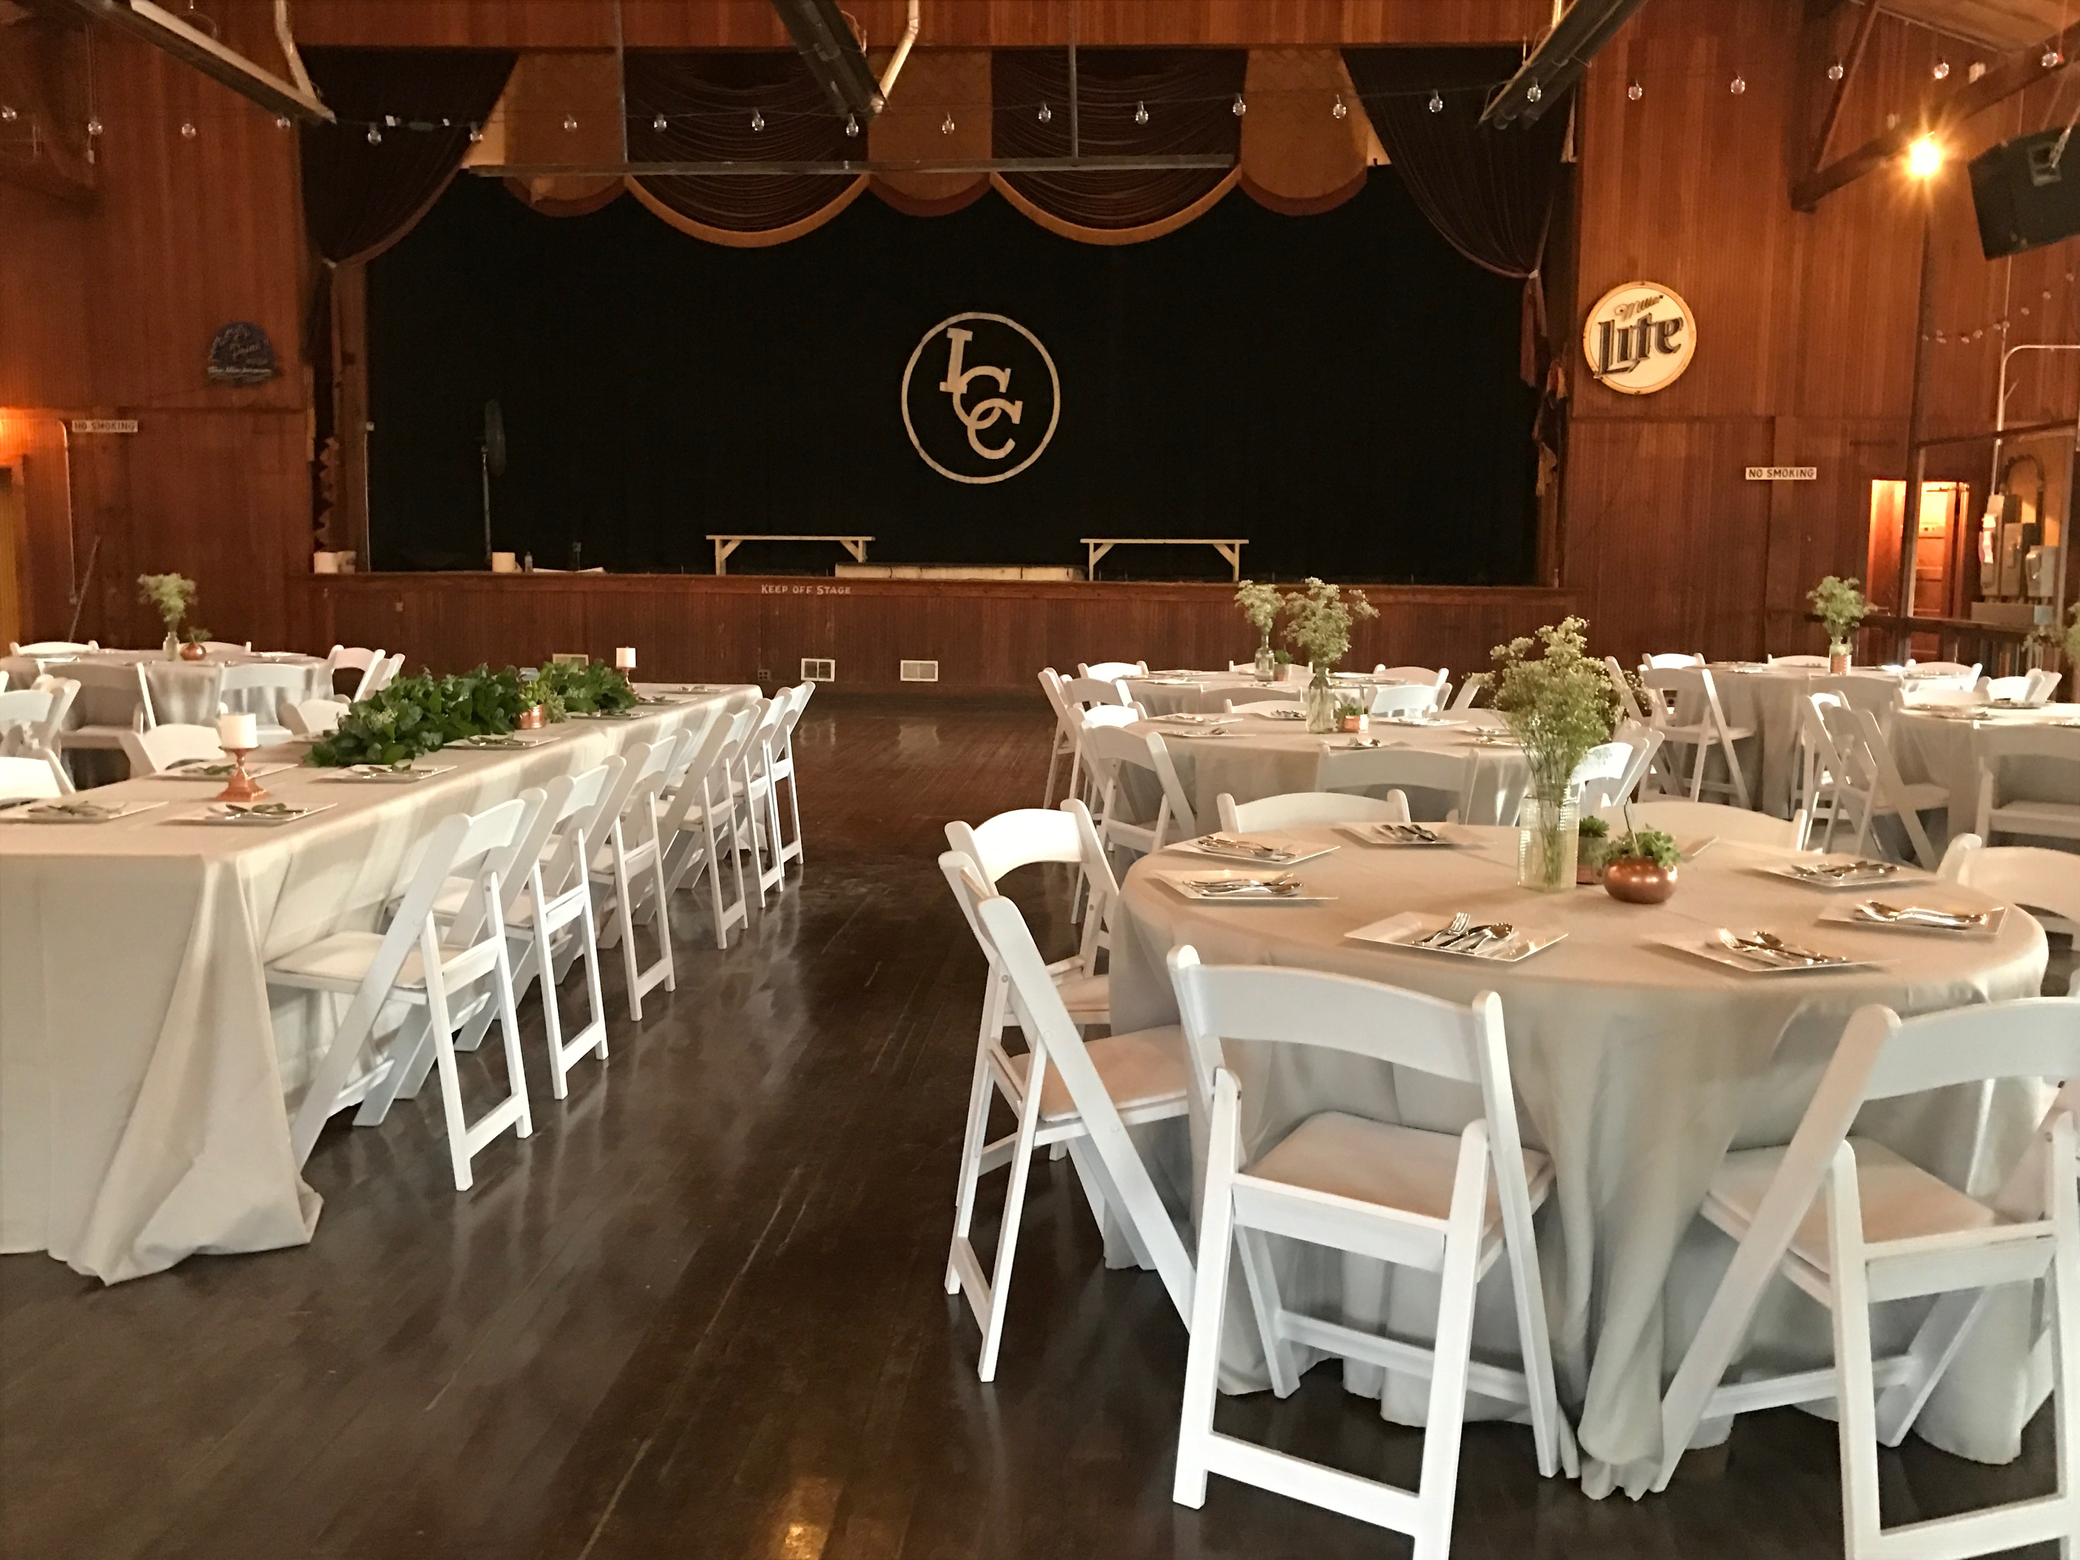
Indian Crossing Casino Dance Hall
The Indian Crossing Casino is not and was not a gambling hall. It is simply a gathering place. The historic wood structure built in 1927 on the 22-lake “Waupaca Chain O’ Lakes” brings nothing but winning memories.
Early artists who played here include Eli Rice and his Dixie Cotton Pickers in 1927 and Deacon Thomas in 1933. In the 1960’s, the 3500-square-foot dance floor was full as bands from around the country made pit stops on their way from Chicago to Minneapolis. Bands more recently on the stage include Dickey Betts, Chris Hillman, Molly Hatchet, Johnny Winter and Paul Cebar.
The Casino has a bar on the porch along the channel between Columbia and Lime Kiln Lakes and serves drinks and food. The hall is available for weddings and other events. Contact by phone 715-258-3332 or management@indiancrossingcasino.com.
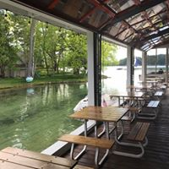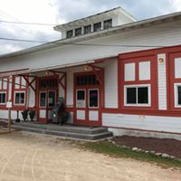
Bar on Porch Casino Entrance

